**STATION 1**

*Match the image shown to the microscope used to capture the image OR match the description to the correct microscope type. Write the letter for the correct microscope. Microscopes can be used more than once as answers. Each numbered question is worth* ***1 point****.*

A. Light Compound Microscope

B. Phase Contrast Microscope

C. Fluorescence Microscope

D. Transmission Electron Microscope

E. Scanning Electron Microscope

1.

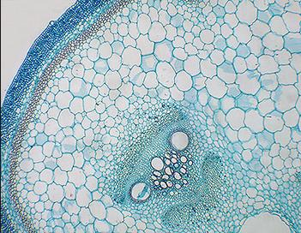

2.

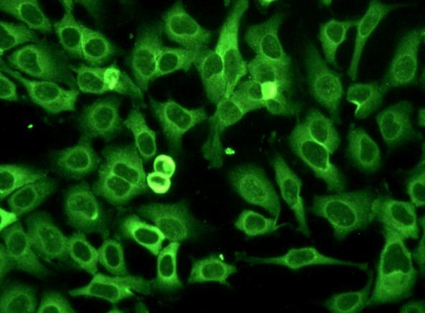

3.

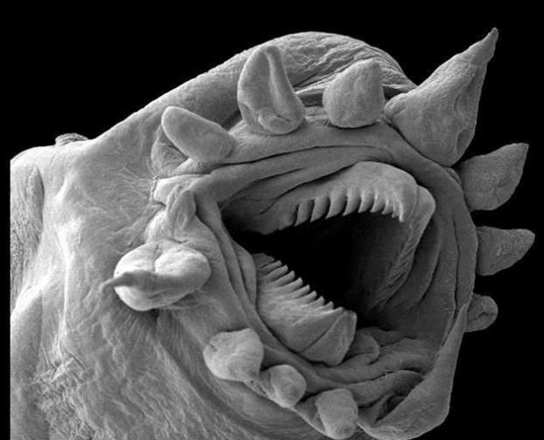

4.

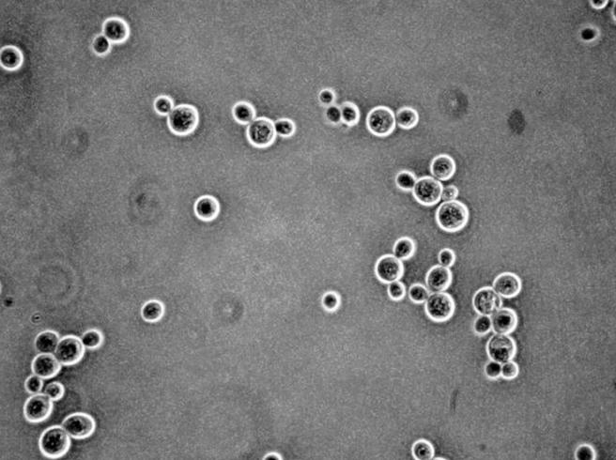

5.

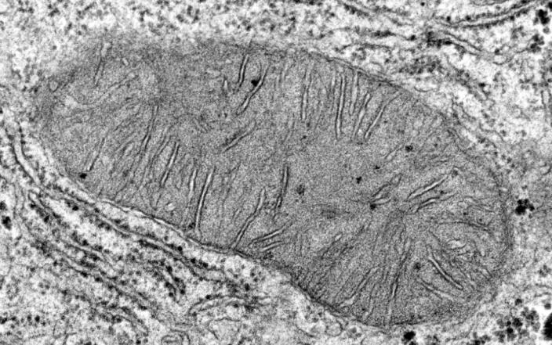

6.

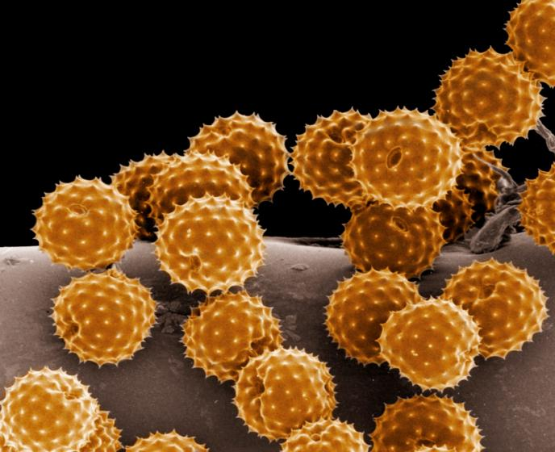

7. Specimen is contrasted against a gray background

8. Creates an extremely detailed three-dimensional view of all kinds of objects

9. Used with dyes that show fluorescence under UV rays

10. Forms its image when light is transmitted through the specimen

11. Often used to view structures of cells and viruses

**STATION 2**

*Each lettered question is worth* ***1 point****.*

PART 1. *Order the following steps for Streaking for Isolation of Bacteria from first step to last with numbers 1,2,3,4,5.*

A. ____Dilute by dragging stick or loop across plate

B. ___Re-sterilize stick or loop with flame

C. ___Spread a heavy streak of cells with a sterile stick or loop

D. ___ Repeat until cells sufficiently diluted to form isolated colonies

E. ___ Pull cells from previous streak

PART 2. *Order the following steps for Serial Dilution and Plating from first step to last wit numbers 1,2,3,4,5.*

A. ___ Spread volumes of each dilution on plates

B. ___ Determine Colony Forming Units per mL of medium

C. ___ Transfer same volume of first dilution to a second tube with the same amount of fresh media, generating a 100-fold dilution, continue until 106 dilution has been made

D. ___ Dilute culture 10-fold

E. ___ Count colonies that form

**STATION 3**

*For each of the following, write a T or F for whether each statement is TRUE or FALSE. Each numbered question is worth* ***1 point****.*

1. Microbes can be involved in maintaining septic tanks.

2. Microbes are involved in parasitic relationships in the rumens of cows.

3. Only bacteria can be used to make antibiotics.

4. Lactic acid bacteria ferment milk into products like yogurt.

5. Microbes are used in the production of chocolate.

6. Most microbes are not beneficial.

7. Lactic acid fermentation helps with bread making.

8. Microbes only function to harm in the production of cheese.

9. Microbes are key in maintaining ecological balance on Earth.

10. Microbes can cause red tide.

**STATION 4**

*Match the following letters for the terms with the descriptions and pictures below. Some terms will be used more than once. Each numbered question is worth* ***1 point****.*

A. Coccus B. Vibrio C. Bacillus

D. Spirillium E. Cocco-bacillus F. Enlarged Rod

1. Rod-shaped

2. Sprial-shaped

3. Comma-shaped

4. Ball-shaped

5. Ovoid-shaped

6.



7.



8.



9.



10.



11.



**STATION 5**

*For each of the following, write a T or F for whether each statement is TRUE or FALSE. Each numbered question is worth* ***1 point****.*

1. Measuring bacterial growth through plate counts uses a spectrophotometer.

2. PCR would be necessary to help quantify the DNA of a bacterial sample.

3. Plate counts can only be done after the plate is streaked by a sterile stick or loop.

4. When measuring bacterial growth with optical density, only living cells make up the data.

5. CFU/mL is the measurement uses for plate counts.

6. When using optical density, more bacteria would lead to less absorbance.

7. Gel electrophoresis is necessary for quantifying the DNA of bacteria.

8. Cellulose is used as the growth medium for plating.

9. Turbidity is used to quantify DNA of bacteria.

10. Bacterial density is often measured at an OD of 600.

**STATION 6**

*For each of the following, write a T or F for whether each statement is TRUE or FALSE. Each numbered question is worth* ***1 point****.*

1. Diatoms are a type of fungus that are important marine microbes.

2. Polio virus is smaller in size than rabies.

3. *E. coli* is a bacteria that is 1/100 the size of yeast.

4. Amoeba commonly use pseudopods.

5. Lactobacillus is a ball-shaped bacteria.

6. Rinovirus causes the common cold.

7. Paramecia are eukaryotic.

8. Viruses are biotic.

9. Chlorophyll can be found in both plants and bacteria.

10. Euglena is only heterotrophic.

**STATION 7**

*Each numbered question is worth* ***1 point****.*

1.What is the magnification of the below image? (WORTH 2 POINTS)

2. What is the actual size, in micrometers, of the organism shown below? Measure from its rear to the eyeball. (WORTH 4 POINTS)

3. What kind of microscope was used to take the image?

4. Is the image of something that is biotic or abiotic?

5. Is the image of something that is a eukaryote or prokaryote?

6. What kingdom does the below picture belong to?

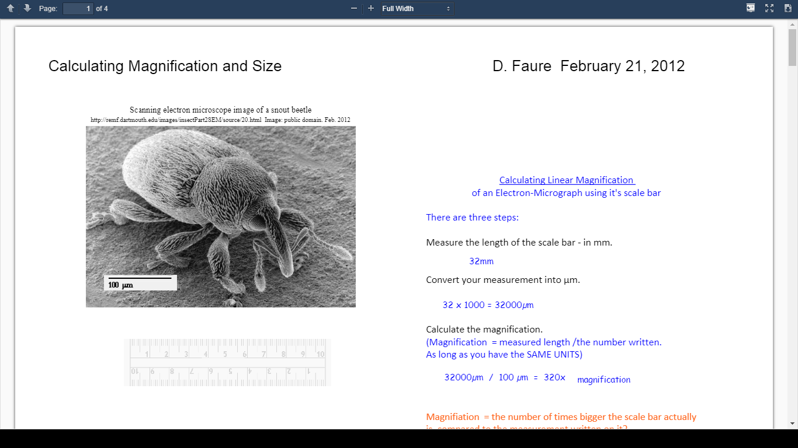

**STATION 8**

*Use the picture below to answer the questions. Each numbered question is worth* ***1 point****.*

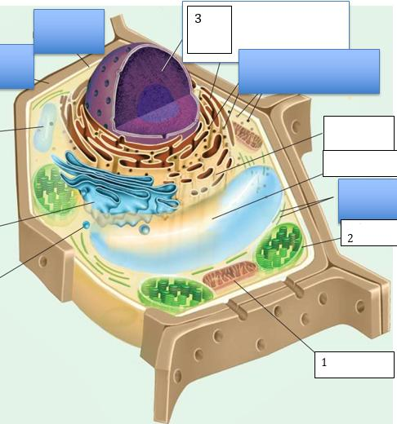

1. What structure is #1?
2. What structure is #2?
3. What structure is #3?
4. Is the above a plant, animal or bacterium?
5. Is the above a prokaryote or eukaryote?
6. What is the main function of #1?
7. What is the main function of #2?
8. What is the main function of #3?
9. What theory describes how structures 1 and 2 ended up in the above cell?
10. What is the main pigment that allows #2 to function?

**STATION 9**

*Use the following graphs to answer the questions below. Each numbered question is worth* ***1 point****.*

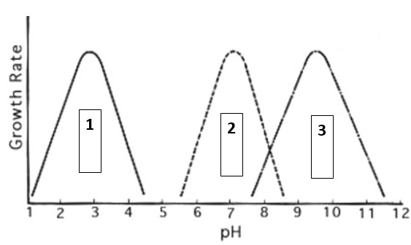

1. Organism 1 grows the best in what conditions: acidic, basic or neutral?
2. Organism 2 grows the best in what conditions: acidic, basic or neutral?
3. Organism 3 grows the best in what conditions: acidic, basic or neutral?
4. Which organism would do best in the stomach of a human?
5. Which organism would do best in the blood stream?
6. If you were to title this graph, what title would you give it?

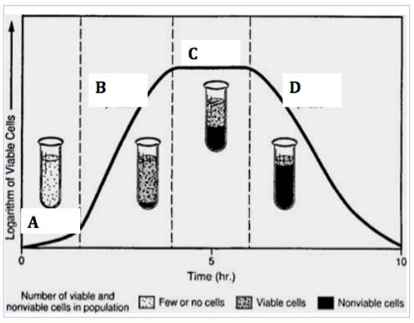

1. What phase is A?
2. What phase is B?
3. What phase is C?
4. What phase is D?

**STATION 10**

*Match the correct description to the correct letter. Some letters are used more than once. Each numbered question is worth* ***1 point****.*

A. Archaea B. Algae C. Protozoa

D. Fungi E. Viruses F. Prions

1. These diseases are characterized by loss of motor control, dementia and paralysis.

2. Multicellular versions of these form hyphae.

3. Extremely tolerant to heat, acid and toxic gases.

4. Can cause dysentery and malaria.

5. Uses cell machinery of host to reproduce.

6. Shells of one type of these are used to make abrasives.

7. These are proteinaceous infectious particles.

8. These can be used in sewage treatment.

9. These are organized by mode of transportation.

10. One teaspoon of topsoil has around 120,000 of these.

**STATION 11**

*Match the correct disease grouping letter with the correct disease. Groupings will be used more than once. Each numbered question is worth* ***1 point****.*

A. Viral Diseases B. Bacterial Diseases

C. Fungal Diseases D. Protozoan/Algal Diseases

E. Parasitic Worms F. Prion Diseases

1. MRSA

2. Malaria

3. Kuru

4. Hookworm

5. Peptic Ulcer Disease

6. Trichinosis

7. Alternaria solani

8. Dengue Fever

9. Chronic Wasting Disease

10. Ringworm

11. Mumps

12. Paralytic Shellfish Poisoning

**STATION 12**

*Match the correct letter(s) with the correct disease. Some diseases will have multiple answers. Each numbered question is worth* ***2 points****.*

A. Eukaryote B. Prokaryote

D. Biotic E. Abiotic

F. Heterotroph G. Autotroph

1. Cryptosporidiosis

2. Zika

3. Anthrax

4. Kuru

5. Tapeworm

6. Chicken Pox

7. Thrush

8. Naegleria

9. Botulism

10. Hepatitis

|  |
| --- |
|  |